Bryan Yukawa – 011627479
HJN1 – HJN1 Task 1: Project approach and prototype
D479 – User Experience Design

Timeline:
Create timeline – 12/31/2025
Understand supporting documents and create user persona – 12/31/2025
Create wireframe for website – 12/31/2025-1/1/2026
Guerrilla usability testing – 1/1/2026-1/2/2026
Interactive prototype creation – 1/2/2026-1/10/2026
Establish objective usability tasks – 1/10/2026

User Persona:
Visitors to the Taniti site will be looking to maximize the enjoyment of their vacation time and simultaneously minimize the associated costs and efforts.

Low-fidelity wireframe:
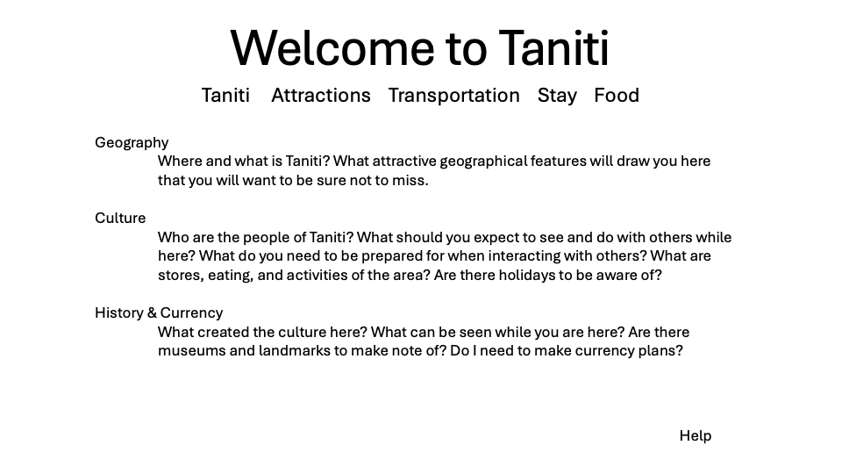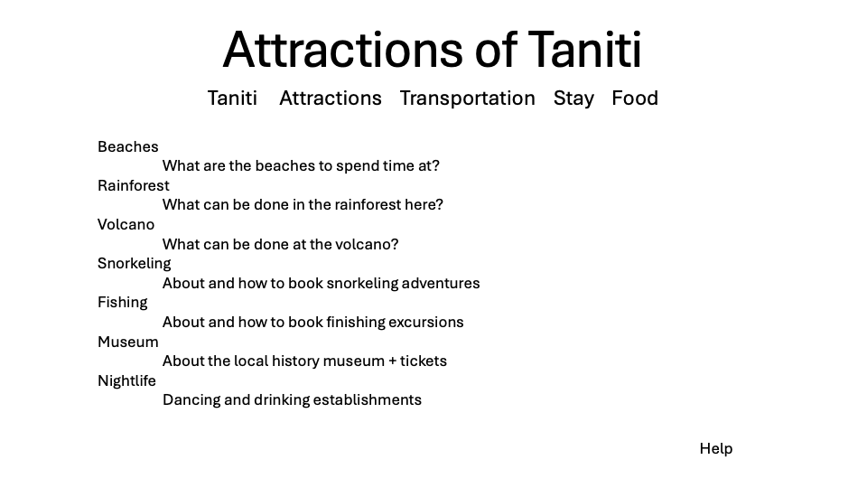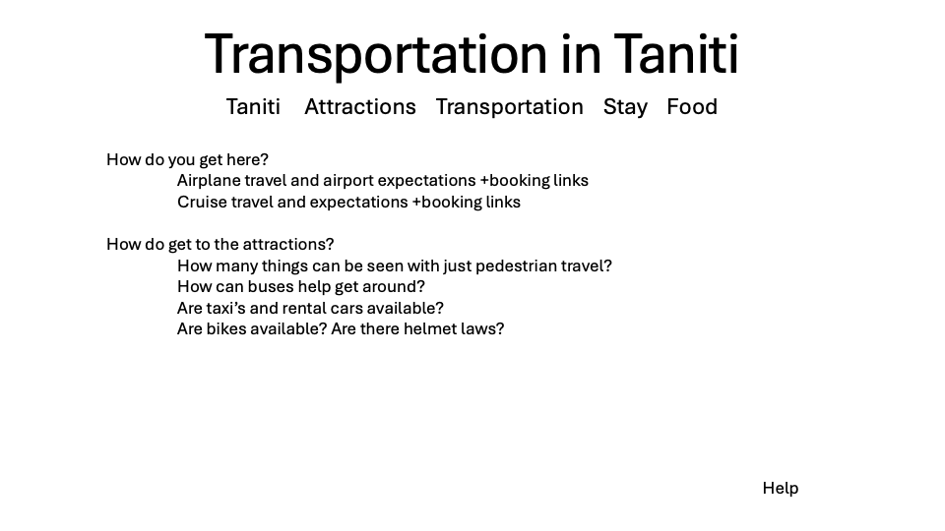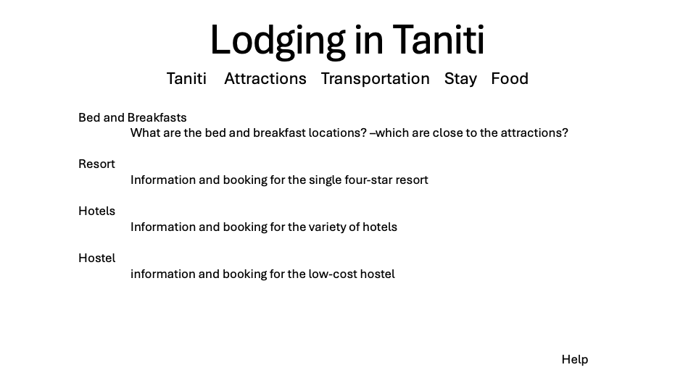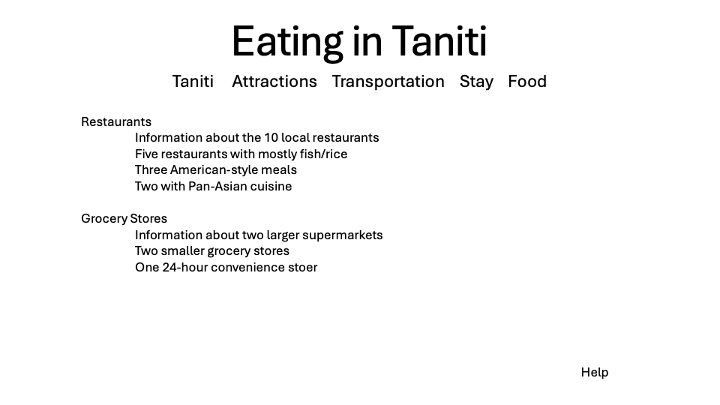
Guerrilla usability testing:
TESTER | FEEDBACK | ACTIONABLE | ACTIONS/CHANGES
Tester1 | Good content and organization, seems like the presentation will come together nicely. Could switch Culture with History & Currency for better presentation. | NO
Tester2 | Overall structure and flow works well. Would love to see more color to create better draw. | YES | Added a color scheme to the backgrounds that should feel more like the view of an island with a sun/sky/cloud theme on the header, the nav links resembling clouds at in the sky, the content floating on rafts in the sky to sea to beach flow in body and the footer as a beach color with the contact button.
Tester3 | Would love to see this more fleshed out and with some color and a less boring structure, seems like an interesting idea. | YES | Created a flexbox structure putting each of the information items on a box that will have a raft-like appearance

Objective Usability Tasks:
- Find information about volcano tours
- Find the type of electrical outlets used on the island
- Find when alcohol cannot be purchased nor served
- Find if helmets are required while riding a bicycle?
- Find where the ziplines can be found?

